CO1-AT3
Name: Boyapati Nandini
Reg No: 192525137
QUESTION 1: Probability Theory
CODE:
from sklearn.datasets import load_breast_cancer
data = load_breast_cancer()
target = data.target
benign = sum(target == 1)
malignant = sum(target == 0)
total = len(target)
p_benign = benign / total
p_malignant = malignant / total
print("Total Samples :", total)
print("Benign :", benign)
print("Malignant :", malignant)
print("\nProbability of Benign =", p_benign)
print("Probability of Malignant =", p_malignant)
if p_benign > p_malignant:
print("\nPrediction: New sample is more likely Benign")
else:
print("\nPrediction: New sample is more likely Malignant")

OUTPUT:
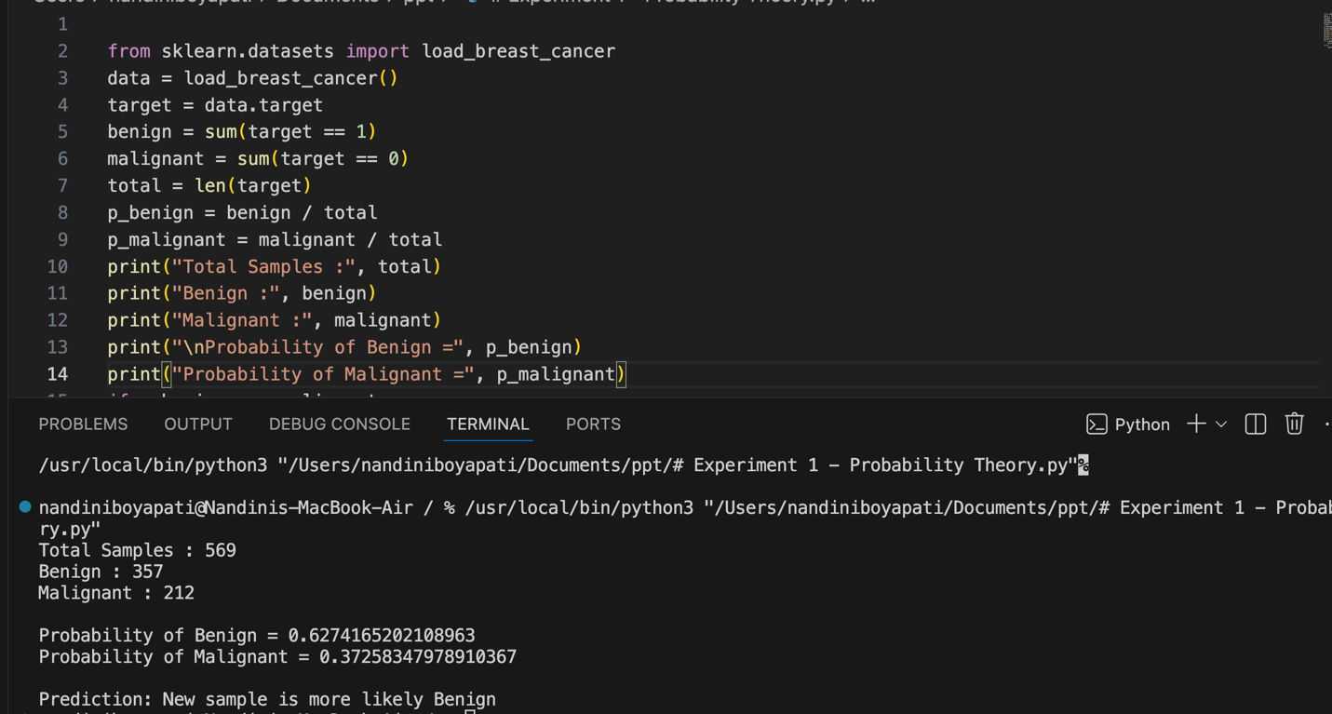

Question 2 : Bayes Decision Theory
CODE:
import pandas as pd
from sklearn.model_selection import train_test_split
from sklearn.feature_extraction.text import CountVectorizer
from sklearn.naive_bayes import MultinomialNB
from sklearn.metrics import accuracy_score
data = pd.read_csv("spam.csv", encoding='latin-1')
# Keep only required columns
data = data[['v1', 'v2']]
data.columns = ['label', 'message']
data['label'] = data['label'].map({'ham':0, 'spam':1})
X_train, X_test, y_train, y_test = train_test_split(
data['message'],
data['label'],
test_size=0.2,
random_state=42
)
cv = CountVectorizer()
X_train = cv.fit_transform(X_train)
X_test = cv.transform(X_test)
model = MultinomialNB()
model.fit(X_train, y_train)
y_pred = model.predict(X_test)
print("Accuracy =", accuracy_score(y_test, y_pred))
msg = ["Congratulations! You won a free lottery ticket."]
msg = cv.transform(msg)
result = model.predict(msg)
if result[0] == 1:
print("Prediction: Spam")
else:
print("Prediction: Ham")
OUTPUT:

QUESTION 3: Information Theory
CODE:
import pandas as pd
from sklearn.preprocessing import LabelEncoder
from sklearn.tree import DecisionTreeClassifier
data = { 'Outlook':['Sunny','Sunny','Overcast','Rain','Rain','Rain','Overcast','Sunny','Sunny','Rain','Sunny','Overcast','Overcast','Rain'], 'Temperature':['Hot','Hot','Hot','Mild','Cool','Cool','Cool','Mild','Cool','Mild','Mild','Mild','Hot','Mild'],
'Humidity':['High','High','High','High','Normal','Normal','Normal','High','Normal','Normal','Normal','High','Normal','High'],
'Wind':['Weak','Strong','Weak','Weak','Weak','Strong','Strong','Weak','Weak','Weak','Strong','Strong','Weak','Strong'],
'Play':['No','No','Yes','Yes','Yes','No','Yes','No','Yes','Yes','Yes','Yes','Yes','No']
}
df = pd.DataFrame(data)
encoder = LabelEncoder()
for column in df.columns:
df[column] = encoder.fit_transform(df[column])
X = df.drop('Play', axis=1)
y = df['Play']
model = DecisionTreeClassifier(criterion='entropy')
model.fit(X, y)
print("Feature Importance (Information Gain):")
for feature, importance in zip(X.columns, model.feature_importances_):
print(feature, ":", round(importance, 3))

OUTPUT:

